院/系（班）___________________ 姓名____________________ 学号_______________

第一章 孟德尔式遗传分析
Mendel’s Laws of Inheritance
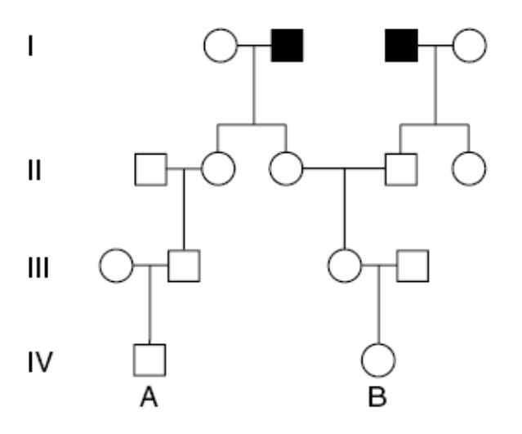
1．（改编自 D4-1, 2nd ed）下图所示的是一个罕见的常染色体隐性遗传病苯丙酮尿症（PKU）的系谱图：
（1）尽可能多地列出各成员的基因型（用 P (p)表示该基因座，将基因型写在图上）。
（2）如果 A 和 B 结婚，则他们的第一个孩子患 PKU 的概率有多大？
（3）如果他们的第一个孩子是正常的，则他们的第二个孩子患 PKU 的概率有多大？
（4）如果他们的第一个孩子患病，则他们的第二个孩子正常的概率有多大？
（假设所有通过婚配进入该家系的个体都未携带该致病基因。）
答：

2．（改编自 D4-2, 2nd ed）在小鼠中，等位基因 A 引起黄色皮毛，纯合时不致死。等位基因 R 可以单独引起黑色皮毛。当 A 和 R 在一起时，引起灰色皮毛；当 a 与 r 在一起时，引起白色皮毛。一只灰毛的雄鼠和一只黄毛的雌鼠杂交，F₁ 的表型如下：3/8 黄毛小鼠，3/8 灰毛小鼠，1/8 黑毛小鼠，1/8 白毛小鼠。请写出两个亲本的基因型。
答：

3．（改编自 D4-5, 2nd ed）假设在矮牵牛（petunia）的花瓣中存在着两种色素——红色和蓝色，二者混合呈现紫色。两种色素的生化合成途径如下图所示。“白色”指该复合物不是色素（色素的缺乏导致形成白色的花瓣）。红色素是由一个黄色的中间产物形成的，这个中间产物在正常情况下浓度很低，因而对花瓣的颜色没有影响。
第三条途径中的复合物在正常情况下对红色素途径和蓝色素途径没有影响，也不参与花瓣中色素的形成，但是，当它的某个中间产物（白色 3）积累到一定浓度时，会被转变为红色素合成途径中的黄色中间产物。
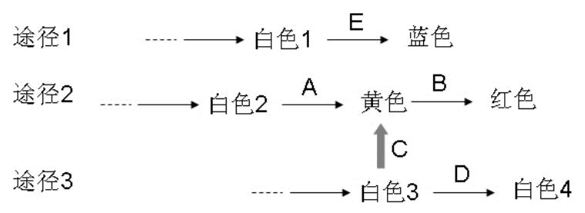
下图中，A 到 E 代表酶；它们相应的基因可以用同一字母的斜体来表示。（假设这些基因是非连锁的。）
假设野生型等位基因呈显性，并且编码有活性的酶；隐性等位基因产物缺乏相应的酶活性。下面列出的是分别从 5 个不同的杂交得到的 F2 的表型及其比率，试推断每一个杂交中能够真实遗传的亲本的基因型。
（1）9 紫色∶3 绿色∶4 蓝色
（2）9 紫色∶3 红色∶3 蓝色∶1 白色
（3）13 紫色∶3 蓝色
（4）9 紫色∶3 红色∶3 绿色∶1 黄色
（5）13 蓝色∶3 紫色
（注意：蓝色和黄色混合形成绿色；假设所有的突变都是非致死的。）
答：

4．(From H3e, 2-36) People with nail-patella syndrome（甲髌骨综合征）have poorly developedor absent kneecaps and nails. Individuals with alkaptonuria（尿黑酸尿症）have arthritis（关节炎）as well as urine that darkens when exposed to air. Both nail-patella syndrome andalkaptonuria are rare phenotypes. In the following pedigree, vertical lines indicate individualswith nail-patella syndrome, while horizontal lines denote individuals with alkaptonuria.
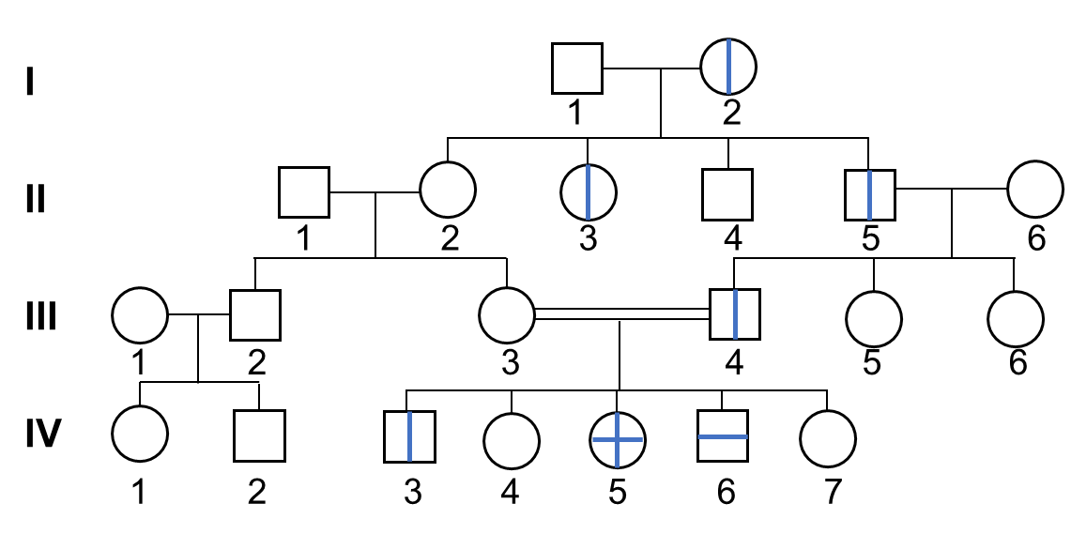
a. What are the most likely modes of inheritance of nail-patella syndrome and alkaptonuria?What genotypes can you ascribe to each of the individuals in the pedigree for both of thesephenotypes?
b. In a mating between IV-2 and IV-5, what is the chance that the child produced would have both nail-patella syndrome and alkaptonuria? Nail-patella syndrome alone? Alkaptonuria alone? Neither defect?
答：

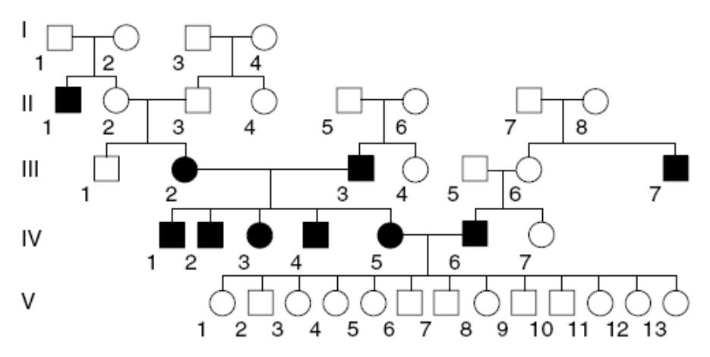
5．(From H3e, 3-22) Filled-in symbols in the pedigree designate individuals suffering from deafness.
a. Study the pedigree and explain how deafness is being inherited.
b. What is the genotype of the individuals in generation V? Why are they not affected?

答：
6．(From H3e, 3-32) A student whose hobby was fishing pulled a very unusual carp out of Cayuga Lake: It had no scales on its body. She decided to investigate whether this strange nude phenotype had a genetic basis. She therefore obtained some inbred carp that were pure-breeding for the wild-type scale phenotype (body covered with scales in a regular pattern) and crossed them with her nude fish. To her surprise, the F1 progeny consisted of wild-type fish and fish with a single linear row of scales on each side in a 1:1 ratio.
a. Can a single gene with two alleles account for this result? Why or why not?
b. To follow up on the first cross, the student allowed the linear fish from the F1 generation tomate with each other. The progeny of this cross consisted of fish with four phenotypes: linear,wild type, nude, and scattered (the latter had a few scales scattered irregularly on the body).The ratio of these phenotypes was 6:3:2:1, respectively. How many genes appear to beinvolved in determining these phenotypes?
c. In parallel, the student allowed the phenotypically wild-type fish from the F1 generation to mate with each other and observed, among their progeny, wild-type and scattered carp in a ratio of 3:1. How many genes with how many alleles appear to determine the difference between wild-type and scattered carp?
d. The student confirmed the conclusions of part c by crossing those scattered carp with her pure-breeding wild-type stock. Diagram the genotypes and phenotypes of the parental, F1 and F2 generations for this cross and indicate the ratios observed.
e. The student attempted to generate a true-breeding nude stock of fish by inbreeding. However, she found that this was impossible. Every time she crossed two nude fish, she found nude and scattered fish in the progeny, in a 2:1 ratio. (The scattered fish from these crosses bred true.) Diagram the phenotypes and genotypes of this gene in a nude × nude cross and explain the altered Mendelian ratio.
f. The student now felt she could explain all of her results. Diagram the genotypes in the linear × linear cross performed by the student (in part b). Show the genotypes of the fourphenotypes observed among the progeny and explain the 6:3:2:1 ratio.
答：

7．(From H3e, 3-36) The garden flower Salpiglossis sinuata (“painted tongue”) comes in many different colors. Several crosses are made between true-breeding parental strains to produce F1 plants, which are in turn self-fertilized to produce F2 progeny.
Parents | F1 phenotypes | F2 phenotypes
red × blue | all red | 102 red, 33 blue
lavender × blue | all lavender | 149 lavender, 51 blue
lavender × red | all bronze | 84 bronze, 43 red, 41 lavender
red × yellow | all red | 133 red, 58 yellow, 43 blue
yellow × blue | all lavender | 183 lavender, 81 yellow, 59 blue

a. State a hypothesis explaining the inheritance of flower color in painted tongues.
b. Assign genotypes to the parents, F1 progeny, and F2 progeny for all five crosses.
c. In a cross between true-breeding yellow and true-breeding lavender plants, all of the F1 progeny are bronze. If you use these F1 plants to produce an F 2generation, what phenotypes in what ratios would you expect? Are there any genotypes that might produce a phenotype that you cannot predict from earlier experiments, and if so, how might this alter the phenotypic ratios among the F2 progeny?

